Run the setup file which is provided in the google drive.

• **Initiate the setup wizard**Locate and double-click the Workstation 14 Pro installer file you downloaded, and click **Yes** on the **User Account Control** box. This initiates the Workstation 14 Pro setup wizard. From this point onward, the setup wizard guides you through the installation process requesting for your inputs wherever needed.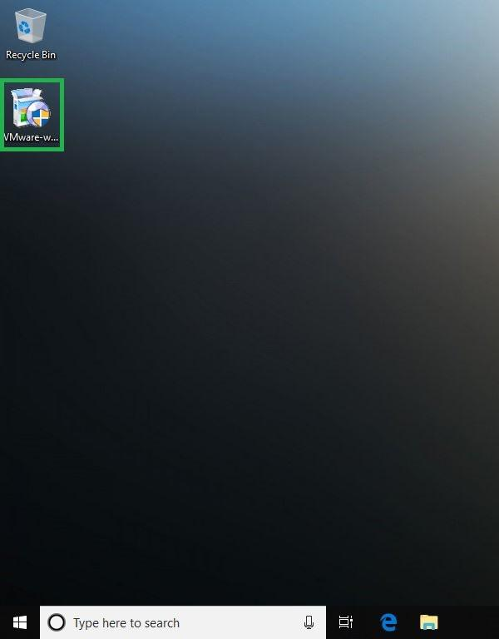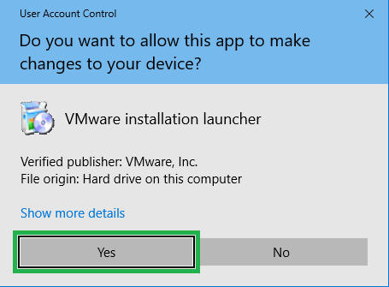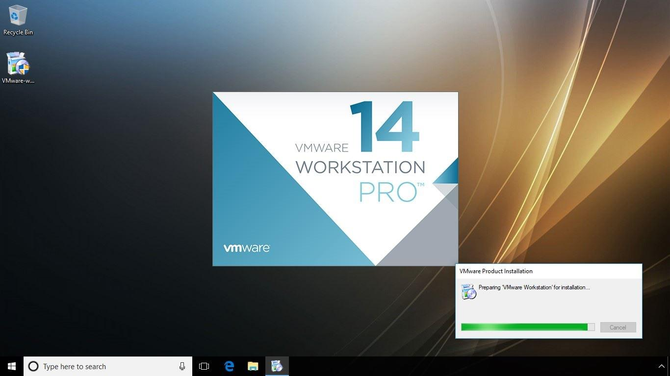

• **Accept the license terms**Click **Next** on the **VMware Workstation Pro Setup** wizard’s welcome screen, carefully read the terms on the **End-User License Agreement** window, check the **I accept the terms in the License Agreement** box, and click **Next**. This tells the program that you agree to the license terms, and takes you to the next window of the wizard. Accepting the license terms is important for the installation process to continue as the **Next** button gets enabled only when you check the **I accept the term in the License Agreement** box.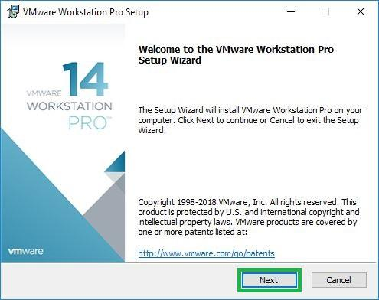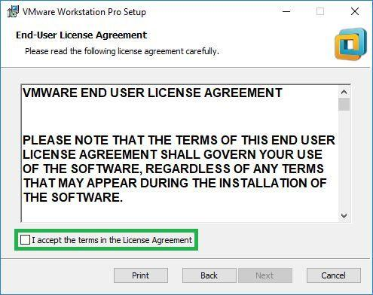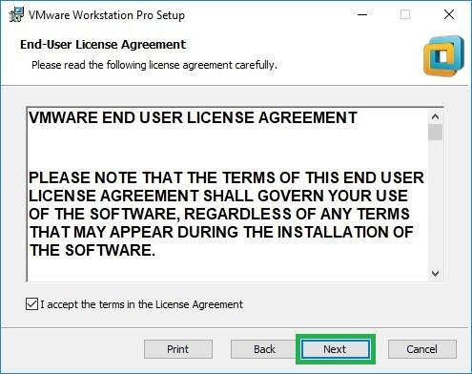

• **Choose keyboard efficiency (optional)**Check the **Enhanced Keyboard Driver** box and click **Next**. This ensures that the keystrokes and special key combinations likes Alt + Ctrl + Delete work correctly and differently for the host computer and virtual machine. As a home user, you can safely leave the box unchecked as it won’t make any noticeable difference while using the program.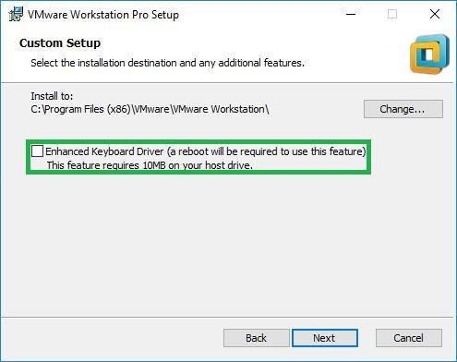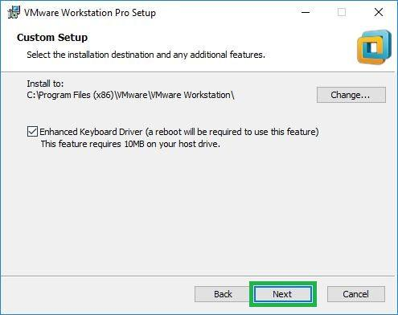

• **Configure user experience settings**Leave the **Check for product updates on startup** and **Join the VMware Customer Experience Improvement Program** boxes checked, or uncheck either or both of them, and click **Next**. Leaving the former box checked performs an online check for any available program updates as soon as it starts and prompts you about them. On the other hand, unchecking the box never checks for product updates. Likewise, leaving the latter box checked sends anonymous data about the program from your PC to VMware team in order to help them improve the app, and unchecking the box keeps your data from being sent.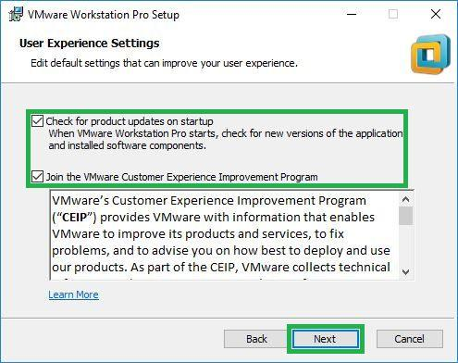

• **Manage shortcuts**Leave the **Desktop** and **Start Menu Programs Folder** boxes checked on the **Shortcuts** window, and click **Next**. This places the Workstation 14 Pro shortcuts on the desktop screen and in the Start menu after the installation completes. Although optional, it’s not recommended to uncheck the boxes as they allow you to quickly initiate the program when needed.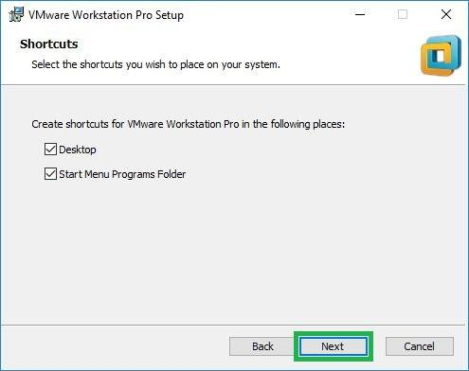

• **Begin installation**Click **Install** on the **Ready to Install VMware Workstation Pro** window, wait while the installation completes, click **Finish** when done, and click **Yes** when the setup prompts you to restart your PC. This installs VMware Workstation 14 Pro on your Windows 10 computer, and configures it correctly upon restart. The installation uses your inputs to configure the program to give you optimum user experience.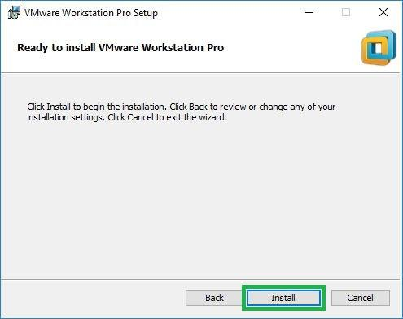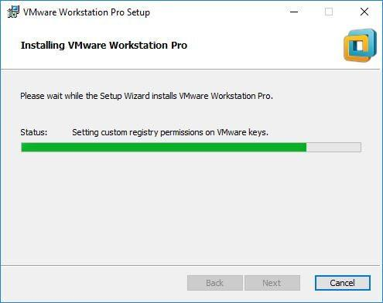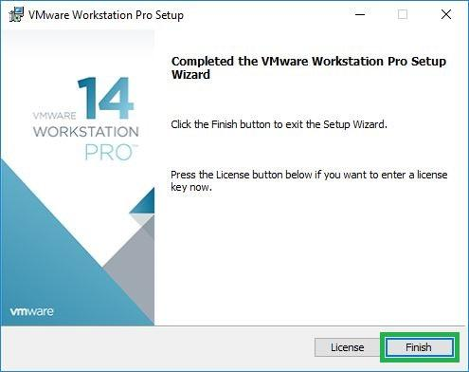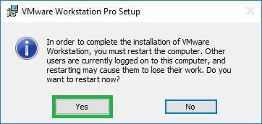**Run VMware Workstation**